

**Digital Tire Management and Monitoring System for Pavara Traders and Services (TireOptiTrack)**

**General Sir John Kotelawala Defence University**

**Faculty of Computing**

Group Member Details

|  |  |  |
| --- | --- | --- |
| Reg.No | Name | Degree |
| 6730 | E. H. M. Diouf | Computer Science |
| D/BSE/23/0015 | T. S. S. Thilakarathna | Software Engineering |
| D/BCE/23/0009 | R. M. J. Jayashan | Computer Engineering |
| D/BCS/23/0018 | B. U. Senanayaka | Computer Science |
| D/BCS/23/0021 | N. T. P. G. B. Upethra | Computer Science |

Supervisor :　Mrs. SCMDS Sirisuriya

February 2024

**01. Introduction**

"Pavara Traders and Services" is a key player in machinery repair and maintenance at the South Asia Gateway Terminals (SAGT) in the bustling port of Colombo. Their varied workload is meticulously organized, with our software development group zooming in on the tire section for our ambitious project.

Within the port's dynamic environment, diverse vehicles and machinery roll in, each with its set of wheels that require careful attention. Pavara's tire checks are timed to perfection, with specific intervals for different vehicle types. They measure not just air pressure and tread depth but also keep tabs on distance traveled, tire crossing patterns, and the tire's status – whether it's brand new or a trusty rethread.

There are various kinds of vehicles and machinery working in the port. Pavara has to check tires of them on time to time (there is a specific time period to check which varying vehicle type to type) of them and manage them without affecting ongoing processes in the port.

Mainly they measure air pressure and tread depth of the tire. And so, distance reading of the vehicle in km, tire crossing pattern, tire status (As new tire, rethreaded tire), tire brands are taken down to get an idea about what is the most effective tire brand for a particular vehicle or machinery.

Then they write all that information in tabled logbooks which are assigned to vehicle type to type. As example one logbook for Prime movers, one for RTGs. Some pictures of them are attached below.

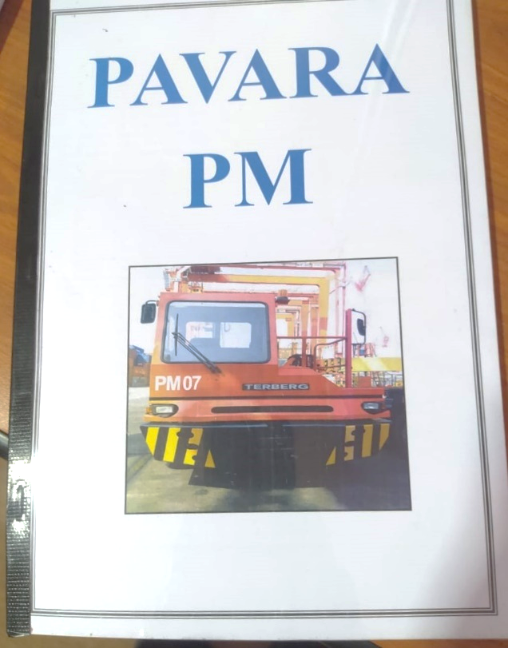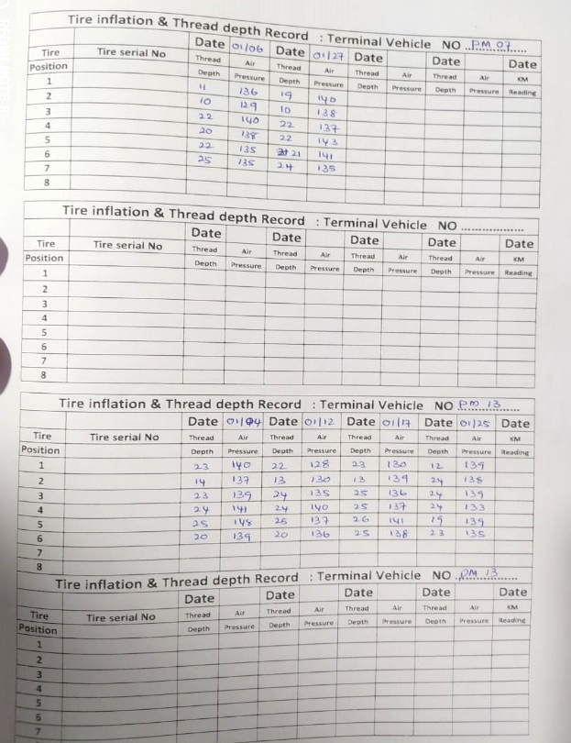

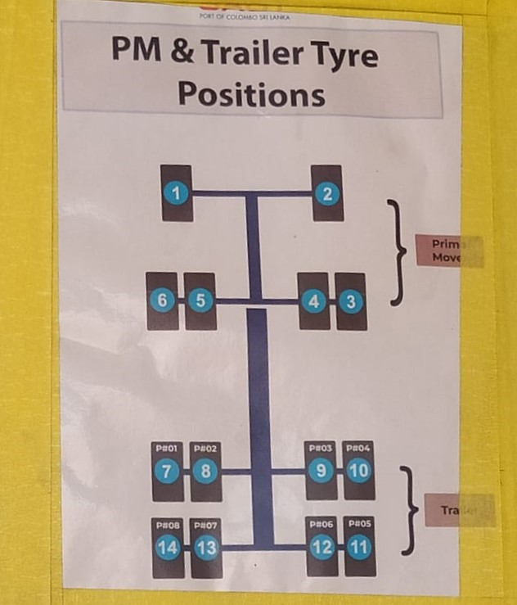



They identify the tire by its serial number and tire position in the vehicle as above structure. They can identify which tire is positioned in which vehicle in which position with the help of vehicle number, tire position number and serial number of the tire.

Keeping track of tire information manually has a few problems. Firstly, using a logbook takes a lot of time and effort for writing, finding, and understanding the data. This slow process makes it hard to manage tires efficiently. Plus, it's not easy to look back at past data to figure out things, which makes it tough to make good decisions about tire maintenance. The lack of real-time monitoring means we might miss important issues, as the manual system relies on periodic checks instead of instant updates. Lastly, relying on paper records can lead to losing or damaging data, making tire management even more complicated.

Therefore, we proposed new software system to them which they can input measured data into a database with computers or mobile phones and monitor data real-time, and get idea about tire performance with visualization parts and without measuring tire predict next measurements with old data, send alerts to users if there are issues in tires, authentication system for different kind of users (for managers and employees).

Introducing a new software system for tire management at Pavara Traders and Services comes with lots of advantages. It makes things faster by reducing the time and effort needed for dealing with tire data. The system also helps in understanding the tire information better. The best part is that it allows for real-time monitoring, so potential problems with tires are spotted right away. The software can even predict future tire measurements using old data, helping plan maintenance in advance. Alerts are sent out if there are any issues, ensuring a quick response. Plus, the system keeps all the tire data safe in one place, reducing the risk of losing or damaging information. With different access levels for managers and employees, it ensures that only the right people can see sensitive details. Overall, this new system makes tire management much easier and efficient for Pavara.

**2. Fact Finding**

**2.1 Justification of Fact-Finding Techniques Used**

Pavara Traders and Services, servicing the South Asia Gateway Terminals (SAGT) at the Port of Colombo, operates within a high-security environment. The stringent security protocols at the port necessitate a detailed process for obtaining passes to enter. This process is time-consuming, posing logistical challenges for simultaneous field visits by our group members due to security restrictions.

To overcome these constraints, we opted for alternative fact-finding techniques that do not require physical presence at the port. Conducting interviews with the client through phone calls and online meetings proved to be a viable solution. This approach allowed us to gather valuable insights into the ongoing tire management processes without the need for physical access. Additionally, we utilized questionnaires to delve deeper into specific aspects of the tire section's operations.

While the option for a field visit remains under consideration, the current security procedures and time constraints make it a complex undertaking. Thus, our chosen fact-finding methods provide a practical and effective alternative for understanding the tire management processes at Pavara Traders and Services, ensuring progress in our project despite the challenges posed by the security protocols at the Port of Colombo.

**2.2 Completeness and Quality of Fact-Finding**

In our pursuit to understand how Pavara Traders and Services manages tires, we had important talks with Mr. C. Wanniarachchi and Mr. R.M. Karunathilaka. These leaders shared valuable insights during our online meetings and class discussions, helping us grasp the details of their current system and what they need in a new one.

We asked about the problems they face with their current tire system and learned about the challenges they tackle every day. From how they measure tire tread depth and air pressure to the time intervals for these measurements, we dived into the nitty-gritty details. Understanding the changes in tire cross patterns and figuring out when a tire is no longer safe for use were also key points in our discussions.

Discovering how many times a tire can bounce back and how to spot faults in vehicles by looking at tire tread details, like problems with wheel alignment, added more layers to our understanding. The conversation also touched on the different tire brands they use and how they decide which brand works best for specific vehicles or machinery.

We didn't stop there. We explored the process of writing down these measurements in logbooks, finding out how they keep a record of tire data. Additionally, we learned how this collected data plays a role in analyzing tire performance. In simpler terms, we wanted to know how they make sense of all these numbers and details to keep the tires and vehicles in top shape.

Our discussions aimed to gather a complete picture of their tire management world. We wanted to make sure we're not missing any important details as we plan to build a new software system tailored to their needs. It's like putting together a puzzle – each piece of information helps us see the whole picture better.

These talks were like a journey where we uncovered the challenges Pavara Traders and Services face in their tire world. From the first turn of the tire wrench to the final logbook entry, every step was explored. We wanted to understand not just the "what" but also the "how" and the "why" behind their tire management processes.

Now armed with this treasure trove of information, we're better equipped to create a software system that fits like a glove. Our aim is to simplify their tire management, making it more efficient and less stressful. And these talks with Mr. C. Wanniarachchi and Mr. R.M. Karunathilaka were the compass guiding us in the right direction.

**03. Description of Current System**

**3.1 Narrative**

Pavara Traders and Services, a machinery repair and maintenance contractor at the Port of Colombo, manages various vehicles and machinery in South Asia Gateway Terminals (SAGT). Their tire management process involves routine checks for vehicles' tires, considering factors like air pressure, tread depth, distance traveled, tire crossing patterns, and tire status (new or rethreaded). This information is manually recorded in logbooks specific to each vehicle type, such as Prime Movers and RTGs. However, this manual process presents challenges, including time-consuming data entry, difficulty in reviewing past data, and the absence of real-time monitoring. To address these issues, a proposed software system aims to streamline the process, allowing for real-time data input, monitoring, predictive maintenance, and enhanced decision-making in tire management.

**3.2 Illustrations Supporting Narrative**

The above two diagrams in the document offer a clear picture of how things work in the current tire management system. The first diagram, similar to a class diagram, shows the relationships and connections between different elements like vehicles, tires, and logbooks. It helps us see how these parts interact in the existing system. The second diagram, resembling a flowchart, lays out the step-by-step journey of tire information, from data collection to manual entry in logbooks, illustrating the challenges of the current process. Both visuals provide a straightforward way to understand the complexities and inefficiencies in the current tire management system.

**3.3 Process Flows**

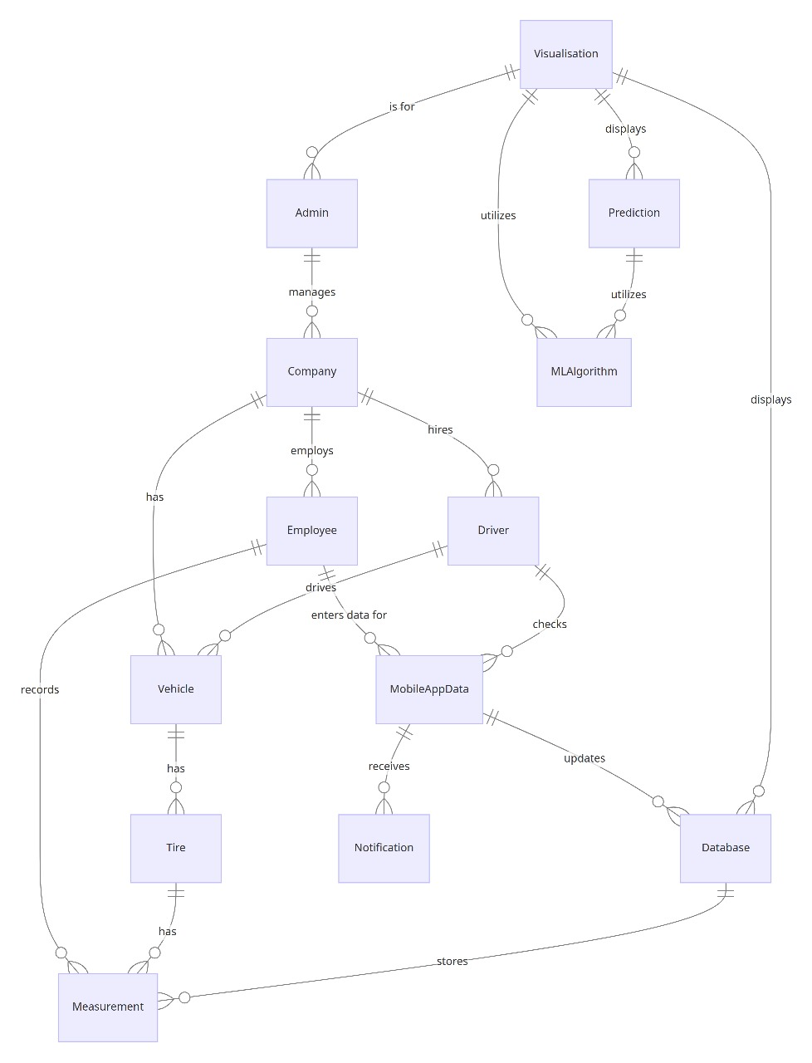

The above diagrams enhance the clarity and understanding of the newly proposed tire management system. The ER diagram visually represents the relationships and entities within the system, providing a comprehensive view of the data structure. It outlines the connections between different elements, such as vehicles, tires, and measurements, facilitating a more intuitive grasp of the system's architecture. These contribute to a visual representation that aids stakeholders in understanding the proposed system's operations, fostering better comprehension and effective communication of the tire management workflow.

**3.4 Problems and Limitations of Current System**

There are limitations in the current system, and we are proposing our new system to avoid those limitations. They are,

1. **Manual Data Entry Challenges:**
   * **Time-Consuming Process:** Recording tire-related information manually in logbooks is a time-consuming task, demanding significant effort from the personnel.
   * **Prone to Errors:** The manual process increases the risk of data reading errors which are written in logbooks such as tire pressure, tread depth, and other metrics.
2. **Inefficiency in Data Retrieval and Analysis:**
   * **Resource-Intensive:** Retrieving data from logbooks and analyzing historical tire information requires considerable resources and effort.
   * **Operational Inefficiency:** The inefficiency in data retrieval and analysis hampers the overall operational efficiency of tire management processes.
3. **Limited Data Analysis Capabilities:**
   * **Cumbersome Historical Data Retrieval:** The manual logbook system makes it cumbersome to retrieve historical tire data, hindering the ability to derive meaningful insights and make informed decisions.
   * **Challenges in Analysis:** Limited data analysis capabilities restrict the depth of analysis, hindering the extraction of valuable insights for effective tire maintenance.
4. **Inability to Make Informed Decisions:**
   * **Lack of Real-Time Monitoring:** The absence of real-time monitoring limits the company's ability to make timely and informed decisions regarding tire replacements, maintenance schedules, and overall operational strategies.
5. **Risk of Overlooking Critical Issues:**
   * **Periodic Checks vs. Continuous Monitoring:** The manual system relies on periodic checks rather than continuous, instantaneous data updates, posing a risk of overlooking critical tire issues.
6. **Dependency on Paper-Based Records:**
   * **Potential for Data Loss or Damage:** Relying on physical logbooks introduces the potential for data loss or damage, complicating the tire management process further.
   * **Organizational Challenges:** Managing and organizing paper-based records for various vehicle types may lead to confusion and inefficiencies.
7. **Complex Identification Process:**
   * **Serial Number Dependency:** Identifying tires based on serial numbers and tire positions in the vehicle structure can be complex and time-consuming.
   * **Limited Information Accessibility:** The current identification process may hinder quick and efficient retrieval of specific tire-related information.
8. **Security Constraints for Field Visits:**
   * **Long Process for Pass Creation:** Conducting field visits to gather information is hindered by the high-security sector, requiring a lengthy process to create passes.
   * **Restricted Access for Group Members:** Security reasons prevent all group members from creating passes and visiting the port simultaneously, limiting their firsthand understanding of the tire management process.

Therefore, to address these challenges and limitations of the current system, we are introducing a new software system for Pavara Traders and Services. This system aims to streamline tire management by enabling real-time data input through computers or mobile phones. It seeks to eliminate manual errors, enhance data analysis capabilities, and provide predictive maintenance insights. The software ensures quick access to historical data, facilitates better decision-making with visualizations, and sends alerts for immediate issue resolution. Additionally, the proposed system offers an authentication feature for different user roles, safeguarding sensitive information. By transitioning from paper-based records to a digital database, the new system aims to overcome the inefficiencies and limitations of the existing manual tire management process.

**3.5 Scope and Constraints**

In defining the scope of our proposed tire management system, we carefully considered the specific needs and challenges faced by Pavara Traders and Services in their current manual processes. The scope focuses on tire data collection, analysis, and predicting to streamline operations within the tire section at South Asia Gateway Terminals (SAGT). This subset of the system is chosen to address the inefficiencies associated with manual logbook entries and limited data analysis capabilities.

**Scope:**

The scope encompasses the development of a user-friendly software system that allows for real-time input of tire measurements using computers or mobile phones. This system will maintain a centralized database, providing instant access to historical tire data, enabling predictive maintenance insights, and facilitating comprehensive data analysis. The software aims to enhance decision-making, improve efficiency, and ensure timely responsiveness to tire-related issues.

**Constraints:**

Several constraints influence the project's scope, including budgetary considerations, technological resources, and time constraints. While the goal is to develop an advanced software system, budget limitations necessitate a balanced approach to ensure cost-effectiveness. Technological constraints may influence the compatibility of the proposed system with existing infrastructure, requiring careful integration.

**Budgetary Constraints:**

* The project must operate within a defined budget to ensure cost-effectiveness.
* Allocation of resources for software development, testing, and implementation is subject to financial constraints.

**Technological Resources:**

* Integration with existing systems and technologies at SAGT needs to be carefully considered.
* Compatibility with different devices, such as computers and mobile phones, presents a technological challenge.

**04. Requirements Specification: Tire Management System**

**Module 1: Authentication and User Management**

1.1: **User Authentication Module**

* Implement support for Single Sign-On (SSO) functionality, allowing users to authenticate across applications using a single set of credentials.
* Provide configurable session management features, including session timeout settings and session invalidation options upon user logout or inactivity.
* Integrate with identity management systems for centralized user authentication and management.

1.2: **User Roles and Permissions**

* Support fine-grained access control mechanisms, allowing administrators to define access rules based on user attributes, such as job title .
* Enable delegation of administrative privileges to designated users or role-based groups for managing user accounts, roles, and permissions.

**Module 2: Data Management**

2.1: **Measurement Data Entry Module**

* Enable offline data entry capabilities for field employees working in remote locations with limited or intermittent internet connectivity.
* Implement data synchronization mechanisms to reconcile offline data entries with the central database once internet connectivity is restored.

2.2: **Tire Stats Visualization Module**

* Support customizable dashboard layouts, allowing users to arrange and configure visualizations according to their preferences and workflow requirements.
* Implement real-time data streaming capabilities to display live updates and streaming data sources in visualizations, such as IoT sensor data from tire monitoring systems.
* Integrate with data annotation and commenting features to enable collaborative analysis and discussion around specific data points or trends within visualizations.

2.3: **Machine Learning Integration**

* Provide model explainability features to help users understand the underlying factors and variables driving machine learning predictions and recommendations.
* Implement model interpretability techniques, such as feature importance analysis and partial dependence plots, to enhance trust and transparency in machine learning-driven decision-making processes.

**Module 3: Database Administration**

3.1: **Database Creation and Management**

* Implement database schema versioning and migration tools to facilitate seamless upgrades and changes to the database structure without disrupting application functionality.
* Enable database sharding and partitioning strategies to horizontally scale the database infrastructure and distribute workload across multiple nodes or clusters for improved performance and reliability.
* Integrate with database monitoring and performance tuning tools to proactively identify and address performance bottlenecks, query optimization opportunities, and resource utilization issues.

**Module 4: Reporting and Alerting**

4.1: **Alerting System**

* Implement support for role-based alert escalation policies, allowing administrators to define escalation chains and notification hierarchies based on user roles, seniority levels, or on-call rotations.
* Provide real-time alerting capabilities with low-latency processing and delivery to ensure timely notification of critical events and anomalies.
* Integrate with incident management systems to automate incident assignment based on alert severity and impact.

4.2: **Reporting Module**

* Support integration with external data sources and APIs to enrich reporting capabilities with contextual data from third-party systems, such as Date and Time and vehicle data.
* system lets users dig into data more deeply. They can pick out what they want to see, break it into smaller parts, and look closely at the details. This helps them find connections and understand the data better.
* Implement data governance and lineage tracking features to ensure data quality, lineage, and lineage integrity throughout the reporting and analytics lifecycle.

**Module 5: User Experience Enhancements**

5.1: **User Profile Management**

* Provide functionality for users to manage their profiles, including updating contact information, preferences, and notification settings.
* Allow users to personalize their user interface layouts.

5.2: **Mobile Compatibility**

* Ensure that the web application is fully responsive and optimized for use on mobile devices, including smartphones and tablets.
* Implement native mobile web application for common platforms to provide seamless access to tire management functionalities on mobile devices.

5.3: **Integration with Fleet Management Systems**

* Integrate with existing fleet management systems to synchronize vehicle and driver information with the tire management system.
* Enable seamless data exchange and interoperability between the tire management system and fleet management software to streamline tire maintenance and fleet operations.

5.4: **Collaboration and Communication Tools**

* Provide built-in communication tools, such as discussion forums, and collaborative document editing capabilities, to facilitate communication and collaboration among company users.
* Enable users to share tire performance insights, best practices, and maintenance recommendations within the system.

5.5: **Training and Documentation Resources**

* Offer comprehensive training materials, including video tutorials, user guides, and knowledge base articles, to educate users on tire management best practices and system functionalities.
* Provide interactive training modules and quizzes to assess user understanding and proficiency in using the tire management system effectively.

5.6: **Employee Support and Helpdesk**

* Establish a dedicated helpdesk or support center to assist users with technical issues, troubleshooting, and system inquiries.
* Offer multiple support channels, including email, phone support to accommodate user preferences and accessibility needs.

5.7: **Mechanism to Identify Data Entry Users**

* Implement user authentication and logging mechanisms to track and identify the employees who enter data into the database.
* Record user identifiers, such as employee IDs or usernames, along with timestamped entries to maintain an audit trail of data entry activities.

**Module 6: Advanced Analytics and Continuous Improvement**

6.1: **Predictive Analytics for Tire Lifecycle**

* Utilize historical tire data and machine learning algorithms to predict tire lifecycle and maintenance needs, including replacement schedules and optimal tire rotation strategies.
* Provide actionable insights and recommendations for improving tire performance, reducing maintenance costs, and maximizing fleet efficiency.

6.2: **Continuous Improvement Feedback Mechanism**

* Implement a feedback mechanism to gather user feedback and suggestions for enhancing system functionality, usability, and performance.
* Solicit input from users, administrators, and stakeholders through surveys, feedback forms, and user forums to drive continuous improvement initiatives.